**RCMS Annual Food Drive**

November 16th – 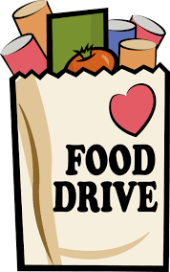December 18th

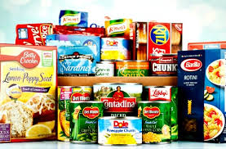

Non-perishable/non-expired items can be dropped off in tubs at Door 1. Items donated will be shared with three food banks on behalf of RCMS students. Thank you for your support!

**Suggested Items:**

* Canned/bagged beans (baked, black, pinto, red, baked, green, lentil, fava beans)
* Gravy (canned or packets), canned pumpkin, canned cranberry sauce, stuffing mix
* Rice, ramen noodles, pasta, jarred pasta sauce, canned/packets of tuna, mac n’ cheese
* Instant mashed potatoes
* Canned tomato sauce, canned fruit/vegetables
* Baking mixes, flour, sugar, brown sugar
* Jell-O/pudding mix, snack items
* Spices, cooking oil, broth
* Oatmeal, cereal, pancake/waffle mix
* Peanut butter, jelly

Please contact Courtney Krsmanovic, School Social Worker

OR Solangie McPherson, Spanish-speaking Parent Liaison if you have questions!